# Contents

# Analysis

## Problem Specification

Some friends want to play a 2d platformer / shooter game with fluid movement and enviroment destruction. It should have a Vs. mode where users fight against each other in an arena until there is only one player alive. It should then move on to the next arena. It should use local multiplayer and platforms should be destructible.

## Stakeholders

### Identifying the Target Market Group

The game I intend to make will likely contain no gore but will likely contain cartoon violence. For this reason the game will likely get a PEGI 7 rating which is the same rating that stick fight (one of the games I researched) was given. This means that I can target my game towards children which increases my TMG. The main group to benefit would be people under 25 e.g. young adults and children. This is beneficial as a large amount of young people regularly play games (in the uk 78% of 16-24 year olds play video games [source: [statista](https://www.statista.com/statistics/300513/gaming-by-demographic-group-uk/#statisticContainer)]).

### The Developer

The developer (me) is one of the main stakeholders. They are the one who is writing the program and doing the majority of the testing. Their goal is to make the platformer game.

### Users

The main group to benefit from the game are going to be the players. Players will be a diverse group of users. They will likely already have some experience of how games work. This means an in depth tutorial on how to use a controller is not necessary, however controls for the game should be similar to other games the users have played as this will avoid a long learning curve for the player which maximises the time they have enjoying the game and minimises the amount of players that give up on the game early on. This is especially important if the game is sold on steam as steam has a 2 hour of gameplay refund policy. A screen should be shown when the player first opens the game which describes what the controls are briefly. Controls should be easy to change and sensitivity should be easy to change.

### Accessibility for Different Users

The game should be usable with many types of controllers including those for people with disabilities. It should also have support for mouse and keyboard as not all players will have access to a controller. options to change colours to make use of the game for colour blind users should be implemented and differences between colours should not be the only difference between two items e.g. different guns should have different shapes and different colours.

Users who do not speak english should be considered so easy methods of choosing language should be implemented even if different languages are not added at the time. This will make further improvements to the game easier in the future.

## Why is it suited to a computational solutions

This problem is well suited for a computational solution for multiple reasons. The solution makes use of computer visuals that need to be rendered on a computer. Also the computation to move and control players can only be done using a computer. There is no solution that would work without a computer.

## Computational thinking methods used in my game:

### Decomposition

The problem can be split into multiple smaller problems that can all be solved with small functions. Here are the smaller problems:

1. Taking inputs from the player
2. Moving the players
3. Checking for collisions
4. Moving bullets

Once each of these problems is done a frame is done and the game can move onto the next frame. This repeats until the player closes the game.

### Abstraction

Players/people, guns and bullets are all represented as 2D shapes.

## Research and Identification of Solutions to the problem

### Platforms for designs

I have considered 3 options for languages to develop the software:

* C++
* Python
* Godot script
* Unity and C#

The benefits of C++ are that it is compiled, fast and a standard for game development, however my knowledge of C++ is not as good as in python and getting help is harder as the language is not taught in my college. Also the libraries for c++ are more difficult to use. Python is slower but it is the language that my college uses which means help is easier to find. Also I have more experience in python. Godot is game engine that I could use to develop my game. It is open source and fast however lots of the complexity in the programming is taken away when developing in a full game engine. Also there is less flexibility for me as the developer to implement features that I want. Unity is another game engine that I considered developing my game in. It is similar to godot but is not open source. The game engine is very popular which means that it easier to develop in as there is more documentation on its features. Also Unity has a few more features than Godot. The main problem with unity is its hostility towards developers. Unity has in the past year imposed fees on users for the download of their games by customers. For this reason I will not be using Unity. Overall I decided on using python for the game.

### Research on python game libraries

I used [this website](https://geekflare.com/python-game-development-libraries-frameworks/) to do research on the best python library to use for game development.

I decided on using Pygame for my game as it will make the development process far quicker since I do not need to spend time handling displays and events. Pygame is the best option as there is good documentation on the python module and lots of information on YouTube and the rest of the web. It is also a fast option compared to other python modules for game development. There are also two options with Pygame: I can use Pygame-ce or I can use the official Pygame. The official Pygame is currently not in development and the owner of the GitHub repository will not let progress continue because of political reasons. Pygame-ce is currently a much more active project. For this reason I plan to use Pygame-ce.

### Looking at other solutions

I found 3 games that I had played I the past which were similar to the game that I want to develop. Prior experience with these games helps me identify the main positives and negatives of each program and decide on what features would best fit my game the best.

### Stick fight:

Pros:

* Fast paced
* Easy local multiplayer
* Contains destruction of platfroms

Cons:

* Not open source so users do not know what the application is doing with their data.
* Costs money which can act as a barrier to entry as some users cannot play the game as they cannot afford the game.
* Online multiplayer can be buggy (teleporting through walls, extreme latency issues, etc.) because the servers are hosted locally on the players computers.
* It can be difficult for controller players to accurately aim as do not have reliable indicator of the direction that they aim. This can cause a disparity of

### Frog Smashers:

Pros:

* Fast paced
* Simple
* Open source

Cons:

* Only controllers can be used. This limits the users as some users may not have a controller or may have only one controller which means they cannot play with friends.
* Very simple game mechanics which can do have variety in the ways they can be used but can get monotonous / boring.
* Uses unity which is first helps with lots of the programming would not show my skills in programming.

### Brawhalla

Pros:

* Fast paced
* Many game mechanics which creates large amounts of complexity and combos
* Has a large amount of active players which reduces queue times for online play
* Various game modes which increases replayability of the game

Cons:

* The game is highly competitive which can create barriers to entry for new players
* The lack of randomness in gameplay can reduce the chance of low skilled players winning which can make the game less enjoyable when playing with friends who are highly skilled. This makes the game less enjoyable as a party game.
* The controls and mechanics of the game are hard to learn. There is large amounts of information on the games mechanics on the wiki but it is not obvious where to find this in game.

One feature in Stick Fight that I liked was the [menu screen](https://drive.google.com/file/d/1VF03cVP2xV6kSCA_54Ucrns5NLPGiZRU/view?usp=drive_link). It uses a diegetic menu which is where game's interface elements exist In-Universe. In this case the players can physically hit each other and move into different rooms to choose whether to play local multiplayer or online multiplayer. The game uses a non diegetic menu for some of the less common parts. Frog smashers also has a diegetic menu that I thought would fit the game. I thought that a combination of these two loading screens would fit the my project best.

I also liked thought that the fact it was not too competitive was a benefit as it fit the games style as a game to play with friends. The randomness of each round means that players who are not so good still win a certain amount of rounds. This keeps the game fun for all players no matter their skill level.

Also the characters in stick fight are [animated algorithmically](https://drive.google.com/file/d/1vix8xcF-g4lRpyzrFqKX_YiRPsHLKbiV/view?usp=drive_link) and depend on the environment around them. This makes the players feel like rag-dolls which fits the game and would fit my game too. This feature however would take lots of time and will not be implemented in the game before the deadline.

I liked the [fast paced mechanics](https://www.youtube.com/watch?v=tfgcT7P_5os&t=62s) in frog smashers and thought that the power up system that is in the game would be good for mine too (different power ups for increased firing speed, reduced recoil, increased movement speed or higher bullet damage). I was thinking of implementing a grapple hook similar to the tongue in frog smashers too. This would be a very latter addition to the game.

One of the most important parts of stick fight that i want to implement is the destruction. The ice platforms can be shot with heavy weapons causing them to fragment into pieces. This would be a good game mechanic to implement into my game but to have it present for all platforms.

With brawhalla the game focuses on competitive gameplay with a weapon pickup system similar to that of stick fights. The picking up of weapons is a feature that I would like to implement into my game as It creates complexity in the gameplay with different weapons providing variety in the gameplay.

### Bullets in other games

Reallistic bullets is important in a game that focuses on gun play. I analysed the bullets in stick fight to determine what I should do in my game to make bullets look good. Here is a [video](https://drive.google.com/file/d/11PVkdxy5DVjoaSnns7CypnW7Pe5-l2Tl/view?usp=drive_link) of bullets in pygame (watch the video in .25 speed by clicking on the cog in the bottom right). In stick fight the bullets are large yellow cone shapes that move quickly. The bullets size depend on the gun they were fired with. The bullets also move very fast but the brightness and size make the direction the bullet is going clear. I think this would fit my game.

### Form Results

I sent out a form using google forms to the target ordinance (gamers in my computer science class) to gather data on gameplay aspects. The people in my sample are all experienced with games. Here are the results: 

1. The majority of players play games on PC or laptop. These are the two devices that I should ensure the game works for. Later porting the game for handheld devices and for consoles would widen my audience.



2. The majority of the players will be using the windows operating system to play games. Some will be using linux. Linux gaming is also a very quickly growing area. These are also the two operating systems that i will be able to test my game on. I may look at making the game available for macOS later on in the development however development in macOS requires the developer to have access to a apple silicon computer. I do not own a apple silicon computer so development in this area will have to wait. If native linux support is too difficult I will have to add documentation on how to use the game with a virtual machine (the virtual machine runs windows and the windows runs the game). The game can be run using Wine and Lutris or using proton. 

3. This shows that I should include a large amount of variety to the gameplay and focus on increasing the amount of content in the game in incremental updates. Also support for modding should also be considered as this allows for users to increase the amount of content in the game with no development from me. Tools for modding should be made public for everyone to use.



4. The sample size for this question was too small to be representative of the TMG. However it did give me ideas on how to increase awareness for the game. As the game will be open source it would be difficult to profit from the game outside of donations. This means that advertising for the game would not be a viable option. However creating videos playing the game is a cost free way to spread awareness and increase the popularity. I may attempt this after development is finished. 

5. Epic Games and Steam are by far the most popular places for people to get their games from. These are two places that I should definitely release the game to if i want the most installs. Itch.io is also a place that I am considering uploading the finished game to as donations can be given which would make me a small amount of money to continue development. I will likely not upload to torrent sites or Xbox and Nintendo stores.



6. The majority of players think that wall jumping is an essential feature and that it should be in the game. Wall jumping is a simple feature that should not be difficult to implement. 

7. I will likely include all of the styles in the game (if I have enough time to) except for the medieval theme since it was the least popular. 

8. The results showed that my users generally have computers with modern high performance GPU's, Large amounts of memory and processors with high clock speeds and multiple cores (that Pygame can take advantage of through parallelization). This means that my users will have plenty of processing power to run the game. I will, however, still try to keep my game as optimized as possible as this will increase the amount of users that are able to play which increases the outreach of my game.



9. Movement around the map was the most important part of gameplay for my users. I will ensure movement is engaging and fun for players. Secrets are also a part that i am considering adding to the game as they may improve the game for long time users as it will increase the amount of content. 

10. Controller and keyboard were split fairly evenly. I am considering adding support for both as this will maximise my player base. And increase accessability for users. It also maximises the amount of players that can play local multiplayer which is very important if the game is “party game”.



11. Surprisingly the majority of respondents thought that G was the best option for throwing a weapon. Ideally a method for changing the keybindings would be implemented but this is unlikely to be done before the deadline for release. Instead I will go with the majority of people and set the G as the key for through.

### Conclusions

My game should be open source and fast paced. It should have support for many different operating systems and input methods. It should also have a large amount of content and have mod support to increase replayability.

## Limitations

One limitation is that I will not be programming all of the system myself as some parts such as displaying to a screen will be handled by the Pygame-ce library. This will make the development quicker and allow me to achieve my objectives. Another limitation is that I will need to complete the project in a short time frame.

## Objectives

* Projectiles/bullets are destroyed when they hit a tile
* Tiles/Platforms can be destroyed by some projectiles
* After enough damage tiles are destroyed
* Tiles turn into a falling tile that is affected by gravity
* Tiles break into 4 rectangles that are affected by gravity
* Tiles break into a few random shaped pieces that are algorithmically generated
* Players are able to walk and interact on the fragments of tiles
* The game should run with FPS over 60 for smooth game play
* NPC enemies which can path find to the player
* NPC enemies that can path find and interact with fragmented of tiles
* Rag-doll players that interact with the enviroment
* The players have animation that changes depending on the speed the player is moving
* After each round players are respawned in the next level and another round starts
* weapons spawn in different places throughout the level
* players can pick up weapons
* players can use weapons
* bullets are emitted from weapons
* bullets can cause damage to a player
* If enough damage is dealt the player will be killed
* when only one player is left alive or there are no players alive the round ends
* when the round ends a new map is loaded
* after a new map is loaded the players are respawned and the new round begins
* the players scores are kept track of and displayed

## System Requirements

### Hardware Requirements

* 100 MB of RAM or higher
* 2GHZ 4 core CPU
* Integrated GPU with 200 MB of VRAM or above
* A keyboard with “QWERTY” layout
* A mouse/ trackpad
* A controller with 2 joysticks, 1 trigger and 4 buttons
* 1024x576 or higher-resolution screen
* 1MB or more free storage space

### Software Requirements

* Any operating system with support for python 3.12 or higher
* Python 3.12 or higher installed
* Pygame-ce installed through pip and in the correct python enviroment
* All necessary drivers for controllers installed

These requirements are based on benchmarking of my hardware at home. The storage space the program takes up will depend on the amount of levels that the player downloads/creates however storage for these is low. The requirements for the program also depend on the frame rate that the user wants to play the game at. Higher frame rates require more computation for the CPU. The GPU usage of the program will be minimal as python does not use the GPU but Pygame does use some of the gpu.

## Success criteria

* Player can move
* Player can walk on tiles
* Player can jump
* Player has animations
* Player has multiple animations depending on how they are moving
* Enviroment has textures
* Enviroment can be destroyed
* Platforms fragment when shot
* Game runs above 60fps on low end hardware
* Players can use a controller to play the game
* Players can use a keyboard to play the game
* Players can pick up weapons
* Players can use weapons
* Bullets interact with the enviroment
* Players know where they are aiming on controller

# Design

## Design Objectives

## Flow Diagram

This is a simplified diagram of how the game will work.

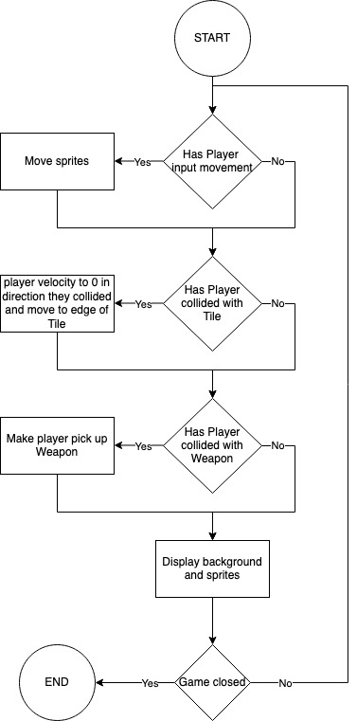

One cycle is completed every frame until the game is closed.

## The Basic Mechanics

The Players will be initialized and loaded into the game. Weapons will be spawned by weapon spawners and the Player will be able to pick these Weapons up. Once there is only one Player alive the living player will be announced as the winner and the next round will be started. To start the next round a new level will be loaded, players will be respawned and all Weapons and Bullets will will be removed.

## Game Design

Below is a simple mock up for the games starting menu screen:

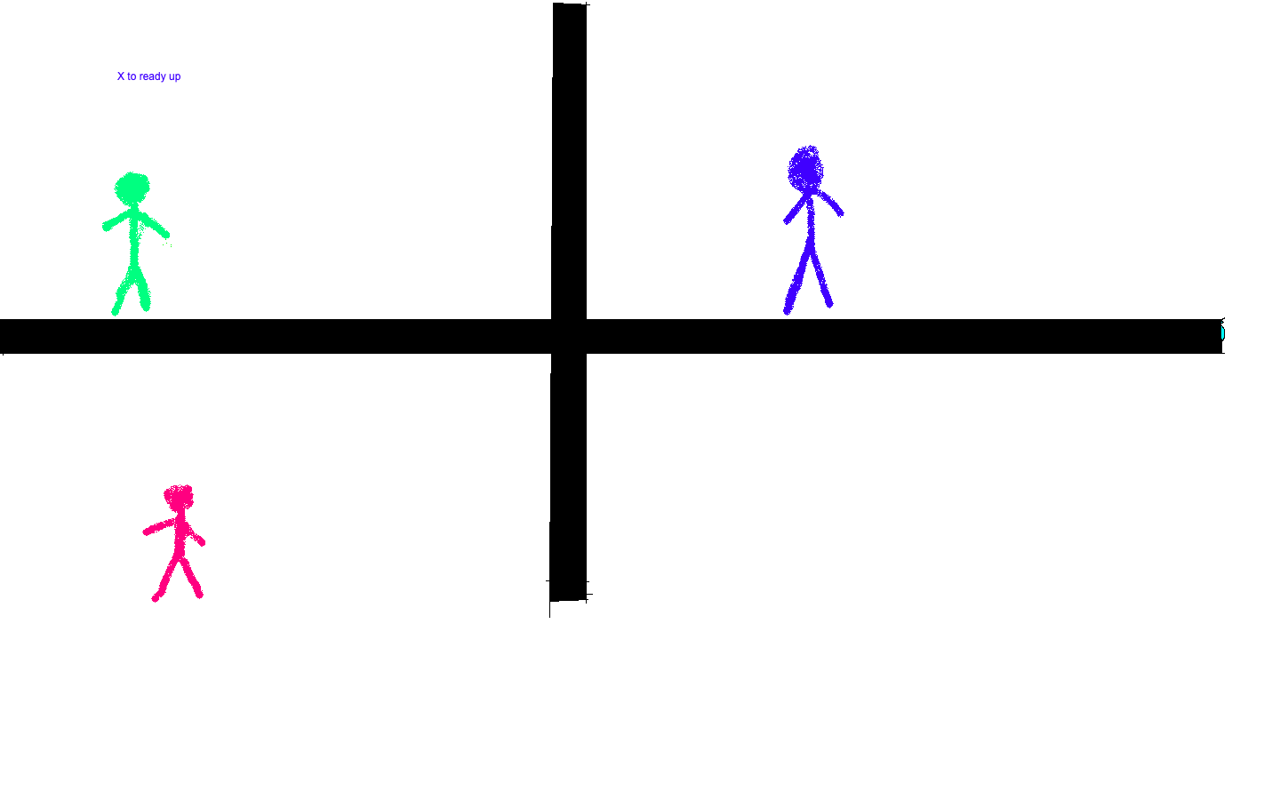The players will be able to press “X” on the controller or “E” on the keyboard to ready up. Once all players have readied up the game will begin and the walls will disappear which will allow the players will be able to fight. Once there is a winner the game will start.

## Settings Menu Design

The settings menu will be accessible by either pressing the escape key on the keyboard or by pressing the “start” button on the controller. This will pause the game and blur the screen then bring up some options over the top. The arrow button will take the player back to the game where they can continue playing. The report bug button will take the player to the GitHub page where they can submit a bug report which will allow for me to find more bugs in my game and improve it. I am aiming to make the settings menu simple to use as that will keeensure players spend as little time changing settings and spend more time playing the game increasing satisfaction with the game.

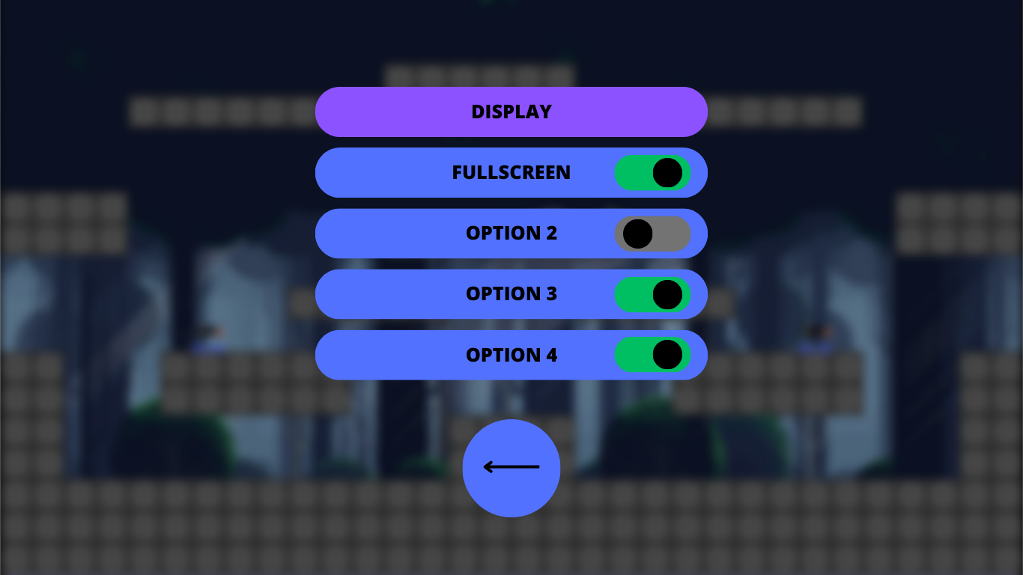

When the player clicks one of the buttons for display, audio or game options a second page will appear where they can change the options.

### Feedback from stakeholders

In a short interview with a stakeholder they said “I think it looks good and looks modern however I’m not sure it fully fits the style of the game. I asked another stakeholder and they agreed so in the future I will redesign the settings menu.

## Creating the Settings Menu

I will be using Tkinter (a pygame library for UI design) for the settings menu as it has large amounts of documentation and there are many tutorial on YouTube and other websites on how to use it. This will aid in the development. Also it is a simple to use and well maintained python library so will continue to be useable with future python updates.

## File Structure

### First Iteration

The game will be stored in a python file called main. This will contain the functions and classes of the game. The game will largely use an object oriented programming style. I will use inheritance for many of the classes in the game.

### Second Iteration

The games functions and classes will be stored in different python files and the files will be imported in places they are needed. This will mean that the code is more readable. For example Player class is stored in player.py. More readable code means that the rate of development is faster understanding and finding the necessary functions is faster.

## Connecting interface devices

The game will use controllers and keyboard to interface with the game. The users can choose what they want to interface with the game with by pressing a button on the keyboard to use it or by connecting a controller to use controllers. This can all be done in the loading menu. The loading menu will prompt the user on what they want to use. A prompt to press any key or connect a controller should be sufficient. Once all the players have pressed a button (e.g. the X button on controller or the E key on keyboard) the game will start. The players will be put into the first level.

The benefit of allowing controller and keyboard inputs is that it increases the amount of people that can play as some people do not have controllers. Also it allows those with both a controller and a keyboard and mouse to choose their favourite input method. The downside is that it means more input need to be added.

## Data structures of my program

Here are some abstracted diagram of the data structures of my game:

### Classes that inherit pygame.sprite.Sprite

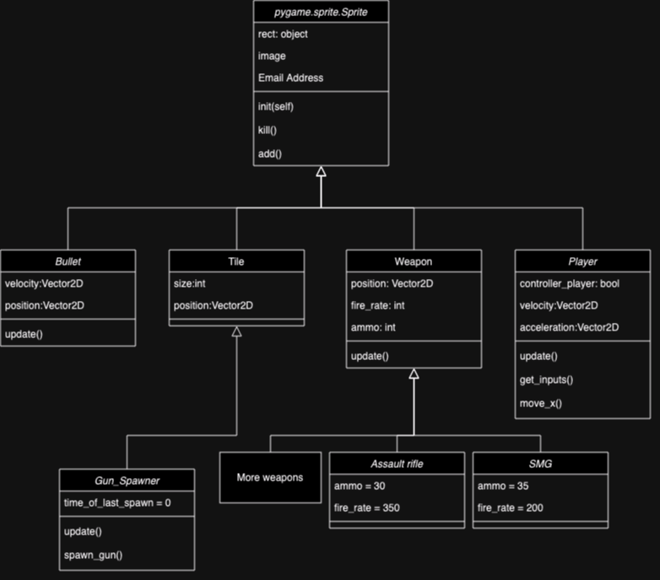

Pygame sprites are classes that have many features such as sprite groups which makes rendering many sprites to the screen far easier. For the weapons I chose to create one superclass that all weapons inherite as this reduces the amount of repetition in the code.

### Other classes

**First Iteration**

In the first iteration of design I stored all the functions and information in each level. Each level has its own set of players, guns and tiles. The levels are all created by a function in the main loop. The levels are stored in a list in the main loop and a counter decides on which level to run.

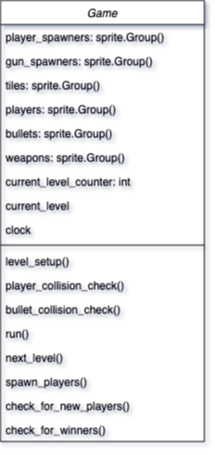

### Second Iteration

The levels are stored in a separate Level class which stores the tiles for the game and other parts that are specific to each level. These levels are stored within a list in the Game class. This allows for the same players to be used in different levels which makes the development of the game easier.

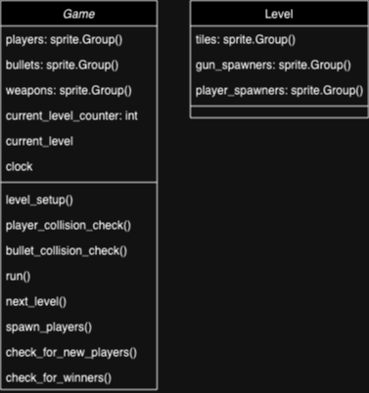

## Destructible Enviroment

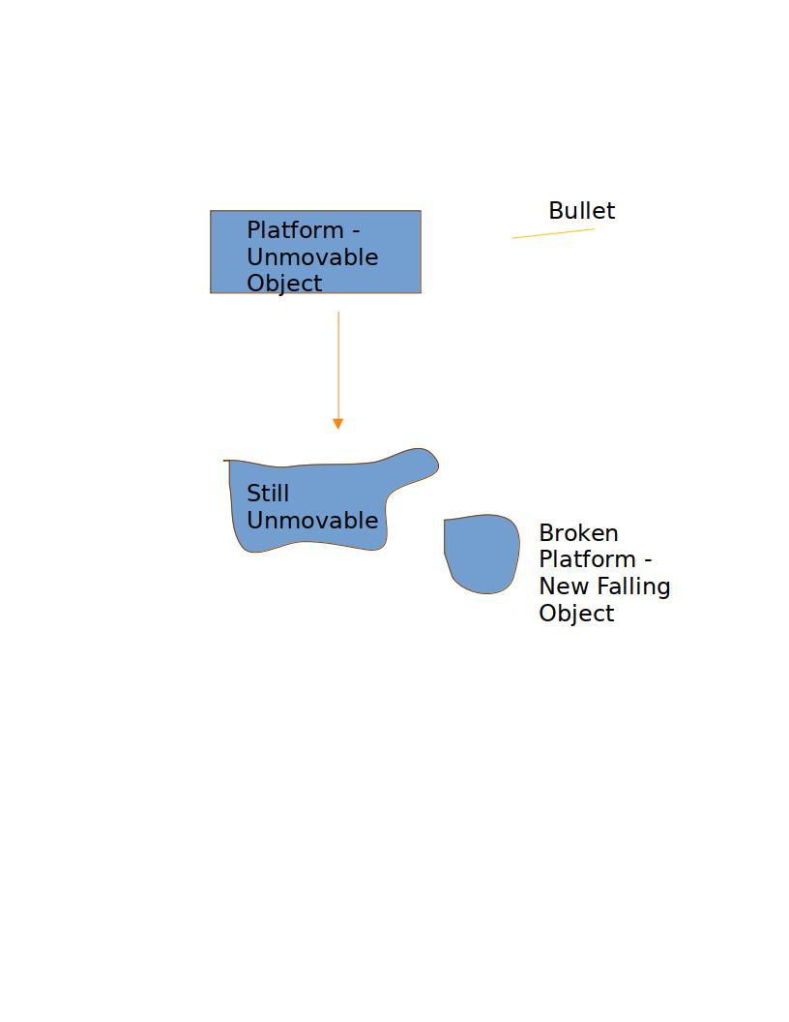In my game I want the tiles that make up the game to be destructible. This means that when shot the tile will break into pieces and fall. To do this I will implement a function that removes a tile if it is impacted by a projectile. The tile will be replaced with some pieces that interact with the tiles around it. To do the interactions with the tiles around I could use Pymunk (a python library for Pygame physics) or I could code my own solution. Coding my own solution will take a lot of research. This may not be within my time scale for the first iteration of the game.

Here is a simple diagram of how the destruction will work:

Here is some pseudo code of how this would work (lines are indented less than they should to increase readability):

def destory_tiles():

for tile in tiles:

for bullet in bullets:

if bullet.collide(tile):

new_moving_tile=Moving_Tile(tile.position)

moving_tiles.add(new_moving_tile)

tile.kill()

This function iterates over the tiles and bullets, checks for collisions, removes of tiles that have been shot and creates a new object in its place. The physics of the Moving_Tile object would be controlled by pymunk or a custom physics system of my own.

## Player movement

### First Iteration

A player will be moved by changing the position that their character is displayed to. For moving horizontally this is done by changing the position by a variable 2D vector called velocity that is given a value dependent on the keys being pressed (if neither the “A” or “D” key is being pressed x_velocity is set to 0) or the direction of the joystick (). The jumping is done by setting the y velocity to be a value. The velocity is then decreased by a gravity acceleration constant. This gives a smooth jump parabola. With the joystick movement the amount that the joystick is pushed can be used to control the movement. Also to decrease the affect that joystick drift (when controllers are used for too long the potentiometers in the motion detector is worn down leading to the joysticks giving false positives for movement) has on the game a joystick has to be moved more than a certain distance to move the player.

Here is the psuedo code (This is not the whole player class):

RUN_SPEED = 2

JUMP_SPEED = 4

GRAVITY = .2

Player(Sprite()):

def __init__(controller_player): #called on intialisation

position = 2dVector(0,0)

velocity = 2dVector(0,0)

def update(): #called on each frame

get_inputs()

apply_gravity()

position += self.velocity

def get_inputs():

if controller_player == false:

#horizontal movement

if get_key(“D”):

velocity.x = VELOCITY

else if get_key(“A”):

velocity.x = VELOCITY * -1

else:

velocity.x = 0

#verticle movement

if get_key(“W”) and on_ground:

velocity.y = JUMP_SPEED

else:

#get joystick is a function that returns a

#2dVector of the joys position (-1 to 1)

joy_position = get_joystick().x

if modulus(joystick_position)>0.2:

velocity.x = joy_position * RUN_SPEED

if get_joystick_button(2):

velocity.y = JUMP_SPEED

def apply_gravity():

velocity.y -= GRAVITY

### Second Iteration

A player will be moved by using an variable 2D vector called acceleration that is dependent on the buttons pressed. This variable is added to the velocity vector each frame which is added to the position. This makes the movement more fluid and realistic as changes in direction are not immediate. I will also use a function that limits the velocity to a maximum that is a constant. When the player is not pressing a button/ pushing a joystick to move in the X direction the velocity of the player will be decreased by a friction constant. I will also use a variable called dt that will be the time that has passed between one frame to another. This stops the framerate the game is running at from affecting the speed that the player moves.

RUN_SPEED = 2

JUMP_SPEED = 4

GRAVITY = .2

Player(Sprite()):

def __init__(controller_player): #called on intialisation

position = 2dVector(0,0)

velocity = 2dVector(0,0)

acceleration = 2dVector(0,0)

def update(): #called on each frame

get_inputs()

apply_gravity()

position += velocity

def get_inputs():

if controller_player == false:

#horizontal movement

if get_key(“D”):

velocity.x = VELOCITY

else if get_key(“A”):

velocity.x = VELOCITY * -1

else:

velocity.x = 0

#verticle movement

if get_key(“W”) and on_ground:

velocity.y = JUMP_SPEED

else:

#get joystick is a function that returns a

#2dVector of the joys position (-1 to 1)

joy_position = get_joystick().x

if modulus(joystick_position)>0.2:

velocity.x = joy_position * RUN_SPEED

if get_joystick_button(2):

velocity.y = JUMP_SPEED

def apply_gravity():

velocity.y -= GRAVITY

def move_x_axis():

velocity.x += acceleration.x

if velocity.x > 0: velocity.x += player_friction

else if velocity<0:velocity.x -= player_friction

if velocity.x > PLAYER_MAX_SPEED:

velocity.x = PLAYER_MAX_SPEED

else if velocity.x < PLAYER_MAX_SPEED:

velocity.x = -PLAYER_MAX_SPEED

if abs(velocity.x) < 0.5: velocity.x = 0

## Player collisions

### First Iteration

This can be done by splitting the movement into the X and Y componenets which makes determining the direction of collision easier. Next the game determines if there was a collisions in each direction and determines the if the player was moved in the positive or negative direction. Finally the game moves the player to one of the sides of the tile and sets the velocity to 0.

def player_collision_check():

for player in players:

player.position.x += player.velocity.x

for tile in tiles:

if player.collide(tile):

if player.velocity.x > 0:

player.position.x = tile.position.x

else if player.velocity.x < 0:

player.position.x = tile.position.x + tile.size

player.velocity = 0

player.position.y += player.velocity.y

for tile in tiles:

if player.collide(tile):

if player.velocity.y > 0:

player.position.y = tile.position

else if player.velocity.y < 0:

player.position.y = tile.position.y + tile.size

player.velocity.y = 0

### Second Iteration

The second way to do this is by checking only the tiles around the player. This reduces the load on the cpu and makes the game O(1) for the number of tiles instead of O(n) which is important for large levels.

## Finding the direction the player is aiming

I will need to design two different functions for this since the controller player and the keyboard and mouse players use different methods of aiming.

### Keyboard

For the keyboard player I need to find the “offset” of the mouse from the player. Then I can divide this offset by the distance of the player from the cursor. This gives a normalised coordinate of where the player is aiming. This can be used to set the velocity of the bullets that the player shoots.

def player_aiming_direction:

mouse_offset_x =mouse.position.x – player.position.x

mouse_offset_y =mouse.position.y – player.position.y

mouse_offset_dist = sqrt(mouse_offset_y ** 2 + mouse_offset_y ** 2)

aim_direction.x = mouse_offset_x / mouse_offset_dist

aim_direction.y = mouse_offset_y / mouse_offset_dist

### Controller

For the controller player I will use the right stick as the method of aiming. We can use the fact that joysticks in pygame give a value that ranges from -1 to 1 for the x and y coordinate.

I also need to account for joystick drift that I have talked about in earlier. I can do this by setting the aim direction to (0,0) if the joysticks are not pushed passed a threshold value.

I also want the left joystick to act as a method of input for aiming when the player is not aiming with the right stick. I will do this in the same way as I did for the right stick.

When neither the left or right stick is being pressed the player will either shoot in the direction they last shot in or they will shoot in a random direction. For the first iteration I will use the random direction method.

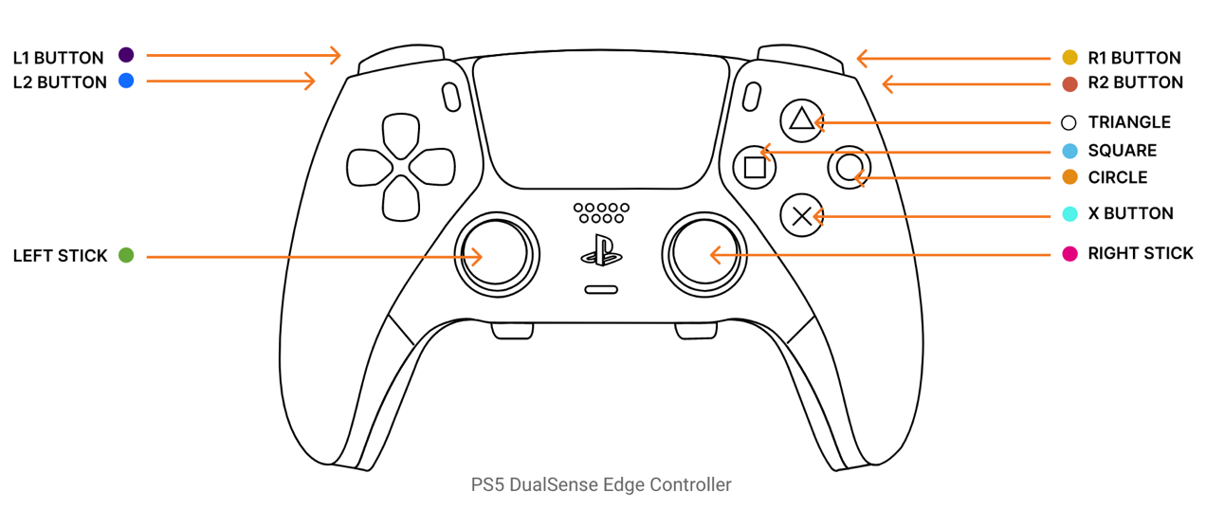

def player_aim_direction:

right_x_offset= controller.right_joystick.position.x

right_y_offset= controller.right_joystick.position.y

right_distance = sqrt(right_x_offset**2 + right_y_offset**2)

left_x_offset=controller.left_joystick.position.x

left_x_offset=controller.left_joystick.position.x

left_distance = sqrt(left_x_offset**2 + left_y_offset**2)

if right_distance > 0.1:

aim_direction.x = right_x_offset

aim_direction.y = right_y_offset

elif left distance > 0.1:

aim_direction.x = left_x_offset

aim_direction.y = left_y_offset

else:

aim_direction.x = 2*random.random()-1

aim_direction.y = 2*random.random()-1

## Displaying the direction the player is aiming

I will only need to display the direction the player is aiming if the player is using a controller as the keyboard players have the cursor to indicate where thir bullets will go.

With the controller players I will use a simple circle (maybe the same colour as the player) to indicate where they will shoot. Their will only be an indicator if the player is aiming with the right joystick. The indicator will be a circle that is drawn relative to the player that is aiming. The position relative to the player will be based of the position of the right joystick.

#a method within the player class to draw aiming #indicator

def draw_aiming_indicator():

offset_x = get_joystick().x * INDICATOR_DISTANCE

offset = get_joystick().y * INDICATOR_DISTANCE

draw_circle(offset_x + player.x,offset_y + player.y)

## Shooting

## Loading in the next level

First the level counter is incremented and the current level is set using the level counter as the index for the level to load. Next all of the bullets and weapons are killed. The players spawned attribute is set to false and the holding attribute is set to none/null. The spawned attribute for all player spawners is set to false and the spawn Players method is run()

## Spawning players

This iterates through every Player in the players sprite group and checks if the players spawned attribute is true. If false the algorithm spawns the player on one of the player spawners that has not been used. This will be a method within the Game object.

To spawn the players the Player object will be moved to the correct position by changing the position coordinates to be the same as the spawners coordinates.

## Permanent Storage

My game will have very little permanent storage as the project does not need to store much information however players are able to edit the level files to add their own levels or to remove levels. This file is not changed by the game but is read by the game for creating the tiles sprite groups. One feature that I could implement is a scoreboard system that stores the best scores that players get in the single player mode in a simple text file. Overall the permentant storage for the game is very small.

## Method of distribution

I plan to use PyInstaller to create an executable. Also for users of different operating systems they will be able to run the game as long as they install python. I will also create a python package which means if someone wants to install the game they will not need to install all the prerequisites such as pygame.

## Deciding between aggregation and composition

Much of my program will use composition. This is where an object only exists within another object. An example of this is the Levels objects that are initialised within the Game object. Composition allows for encapsulation of the functionality of the contained objects within the container. This keeps the code clean and clear. Also the composition implies ownership which is true of the classes within my program. The Players, Levels, Weapons and Bullets are all owned by the Game object.

## Testing

I will be using white box integration testing. This means I will have complete view of the code behind the program and I will be testing all parts of the game by playing the game. I have considered using unit testing but with my game many parts rely on other parts of the game integration testing makes the most sense. I will also be using beta testing to test the game on a sample of the TMG (primarily people in my computer science class as they are a close match to my TMG)

## Validation

Inputs should be validated to ensure the correct data is being inputted. These are the types of data that can be input:

### Keyboard buttons and Controller inputs

All of the keyboard buttons and joystick inputs are input through pygame. I can use selection and a pygame function to check if a button is being pressed. Selection can also be used to determine if the player should be able to press a button (validation):

* If the player is on the ground then they can jump with “W” key or the “A” button on controller
* If the player is intersecting a weapon they can pick up the weapon with “E” key or the “Y” button on controller
* If the player is holding a weapon they can use the weapon with mouse click or right trigger on controller. Also on controller the user must push the trigger further than a set point for a bullet to be shot. This reduces the amount of accidental shots from slight presses of the trigger.

### Reducing the effects of stick drift in my game

Stick drift is where a controllers detect a movement when the joystick is not being moved. This happens because of wear on the potentiometers and because of badly designed controllers. To conteract this the player only moves when the stick is pushed beyond a set point defined as a constant. This stops the player sliding with bad controllers or aiming in a direction they do not want to.

### Sliders

These can be handled by tkinter to input data for the settings menu. Tkinter has a UI that can be useful for designing the menu system. Users should only be able to move the slider to a maximum and minimum value.

### Toggle switches

These can be toggled on or off. These will also be handled by tkinter. When on the user should only be able to switch them off and when off they should only be able to switch them on

## Inputs and Outputs

|  |  |  |
| --- | --- | --- |
| **Input** | **Process** | **Output** |
| The “D” or “A” key is pressed on the keyboard OR left or right on the joystick of controller | The Players x position is increased or decreased to move the player | The image of the Player will move and animation will change |
| The “W” key is pressed on the keyboard OR the “A” button is pressed on the controller | The Players y velocity is increased. | The Player will first move upwards then slow before moving downwards towards the floor. They jump. |
| When holding a weapon the player clicks the mouse or the y button on the controller. | A bullet is created and moves in a the direction the player is aiming. | The player shoots. |
| The Player moves the mouse in a direction. | The program finds the direction of the mouse from the Player | The Player aims in that direction |
| The Player moves the right joystick in a direction | The Player finds the direction of the joystick | The Player aims in that direction |
|  |  |  |
|  |  |  |
|  |  |  |
|  |  |  |
|  |  |  |
|  |  |  |

## Subroutines

Development

## Displaying the levels

### ****Creating a basic game loop****:

The first step of development was creating the basic game loop and displaying a simple shape to the screen. I used code from the [Pygame documents](https://www.pyga.me/docs) to create the basic loop. I used the pygame.draw function to draw a circle to the screen.

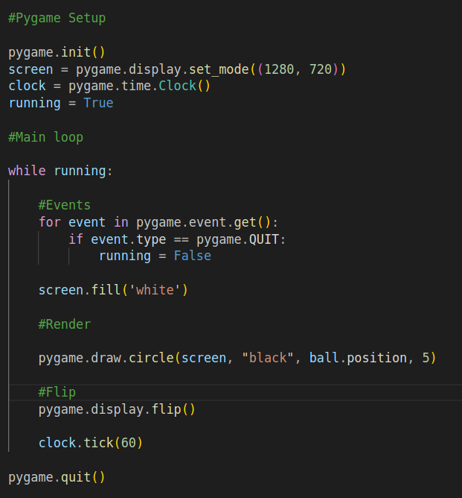

When this code runs run it creates a window and displays this to the screen:

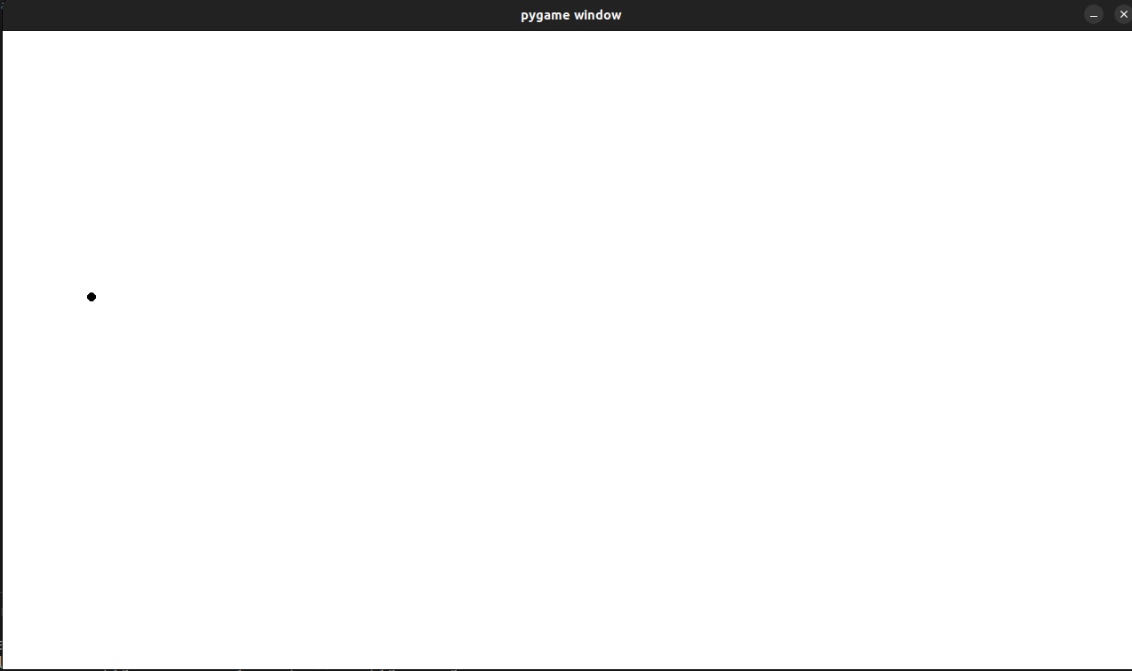

I was happy with the result so moved on.

### ****Displaying a level****

I created a class called Tile() that is a sub class of Pygame.sprite.Sprite. This takes in a position and sets the coordinates of the rectangle to be drawn at that position.

To test this I created a test tile and drew it to the screen:

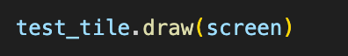

This worked without any problems:



I also created a method that uses a string to get the layout of the level. The function determines where each of the tiles should go based on its position in the list of strings. It then initiates a Tile with the position and adds it to a sprite group called self.tiles. Sprite groups are a feature of Pygame that allow for rendering a group of sprites all at once.

The method is a member of the level class that stores the string that makes up the level. It is called in the initialization of the level object and creates the self.tiles sprite group.

The code for these is below:

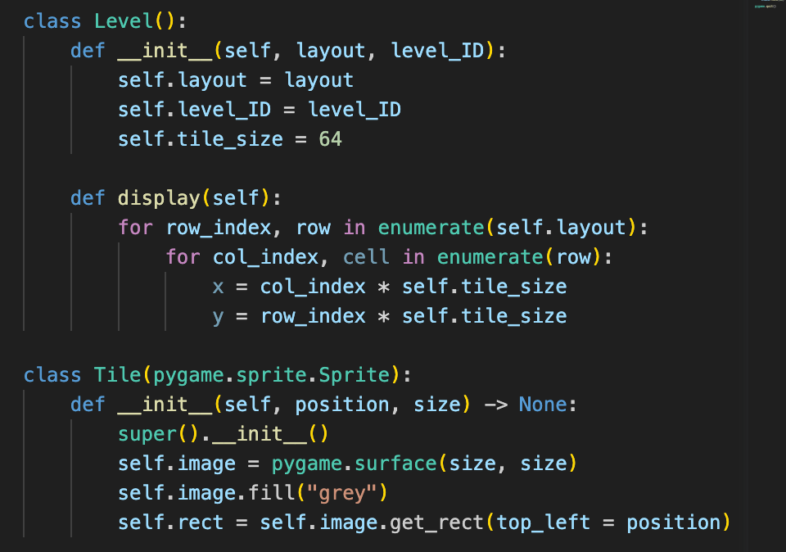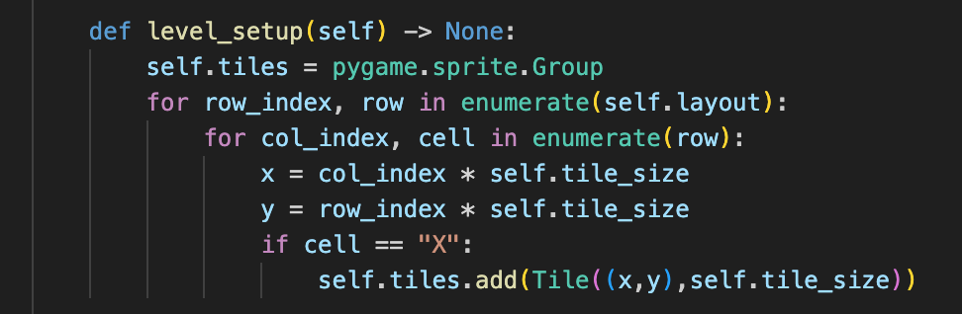

I removed the test Tile and tested the game with a test level instead. The test level was just a list of strings. Here was the result after debugging syntax errors:

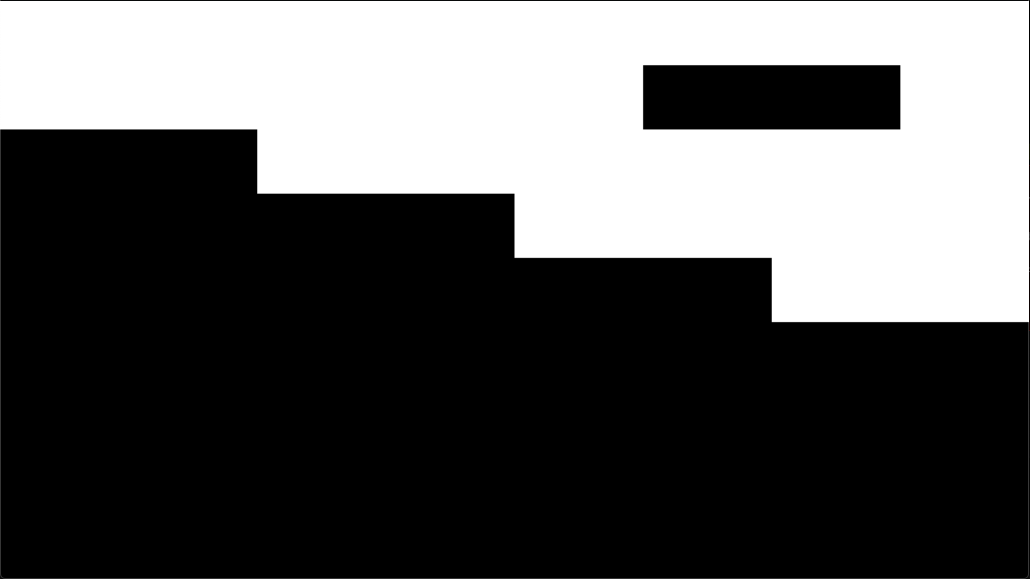

**Storing levels in txt files**

first I created a levels folder which contained some txt files containing the layout of the game. I used the built in os library to create a simple program that I made in a separate python file.

The program opens a directory and iterates through the folders in that directory it creates a list and for each file it iterates through the lines then appends each line to the list. This puts it in the same format as the level_setup method likes.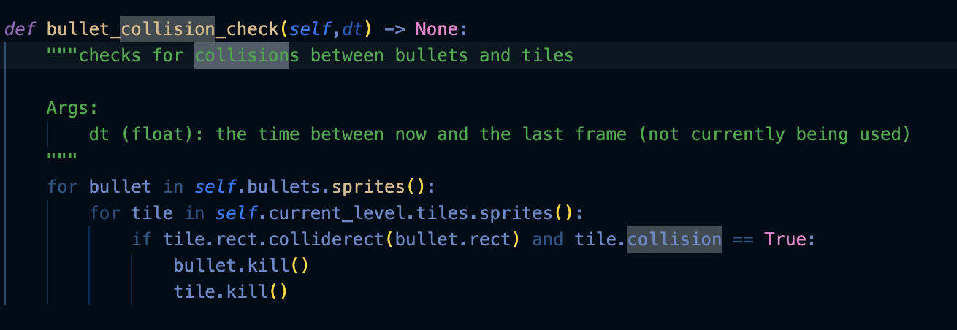

At first when testing I found that the contained \n at the end of each line. 

To fix this I used the strip() function to remove “\n” from each line. This worked and when testing a second time the program printed this to the terminal.



There is no \n in the strings so they a can be used by the function properly.

## Creating the Player

First I made a class called Player that was a subclass of the pygame.sprite.Sprite. I gave it a red image for testing and also added some logic for checking if the some buttons on the keyboard were pressed (the WASD keys) so that the player would move in those directions if they were pressed.

Next I added a function in the level program that detects collisions. This differed from the algorithm proposed in design slightly as it used a few parts of pygame to check if there was a collision ( the colliderect method) and also used parts of sprite rects such as left and right position.

Here is the code I used for the collision_check for the player:

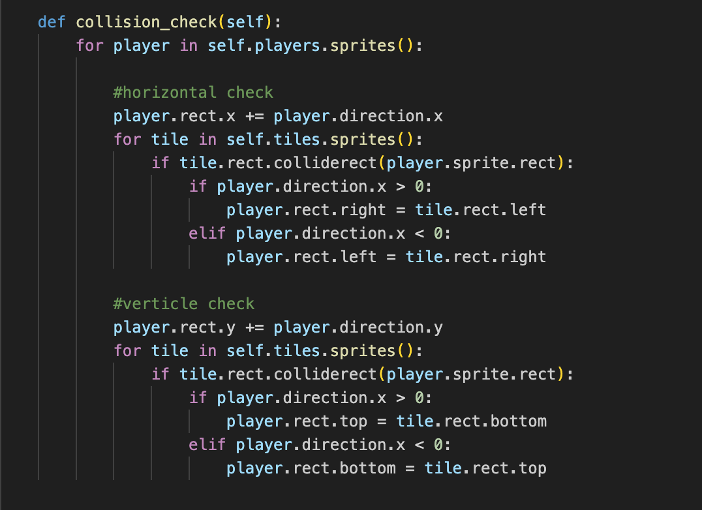

This was a method within the Level class.

After testing the program collision worked properly however the player could move in any direction they wanted as there is no method for the player that adds gravity.

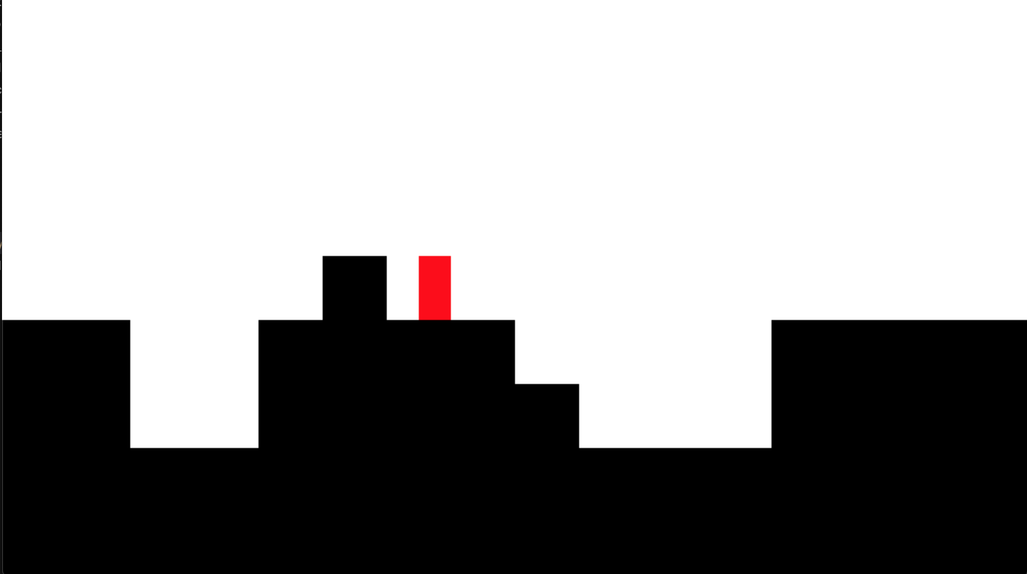

### ****Gravity****

To add gravity I created a method in player called add gravity that added a constant (called GRAVITY) to the y velocity of the player. This means that if the player is in the air they will be accelerate towards the ground. Also the “W” key on the keyboard changes the players velocity to an a constant amount but can only be pressed if the player is on the ground.

**Finding the aim direction and displaying indicators**

At first I implemented a function similar to that of the design however I found that the speed of bullets was dependent on how far the joystick was being pushed from its normal position. This was not what I wanted as bullets differed in speeds. To fix this I normalised the directions. This means that I divided both the x and y offsets by the distance from the center. Here is the code for this function. Here is the code I used.

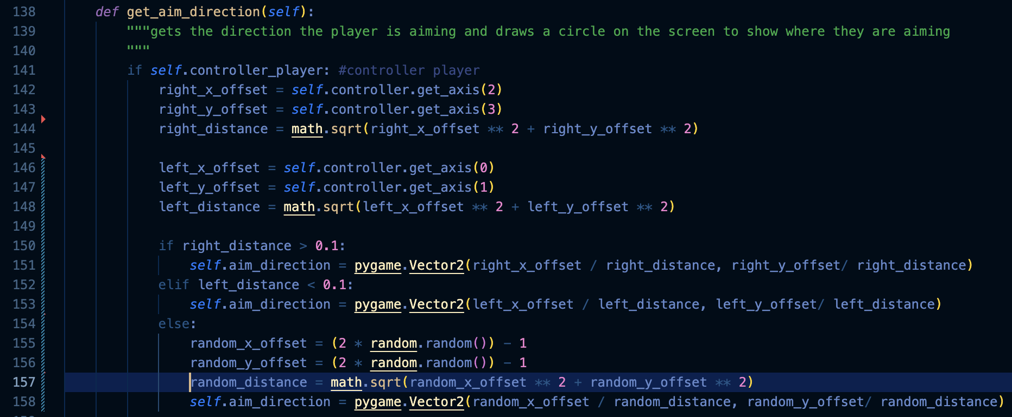

This worked well. All bullets were travelling at the same speed no matter the position of the joystick

Next I needed to display the direction that player is aiming. I did this by displaying a small circle with the coordinates of the player plus an offset. In testing I found that the cursor did not seam to be centered around the middle of the player as it should. To fix this I added the half the width and height of the player to the aim_cursor_position. Here is the code that I used:



Here is an image of the cursors:

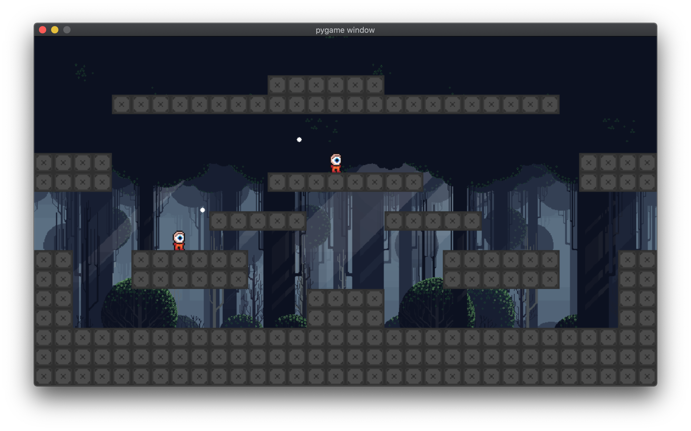

They appeared to be centered around the player so I moved onto weapons.

## Weapons in my game

### Weapon class

The Weapon class is a sub class of sprite class. It is used as a super class for all of the individual weapons.

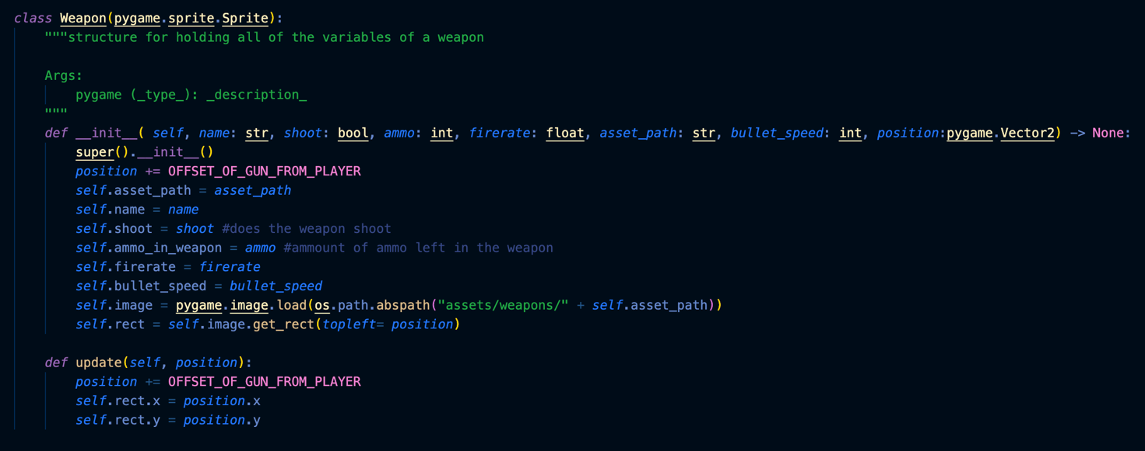

It has attributes for a few different things that each weapon needs.

Here are two examples for the ak47 and smg classes:

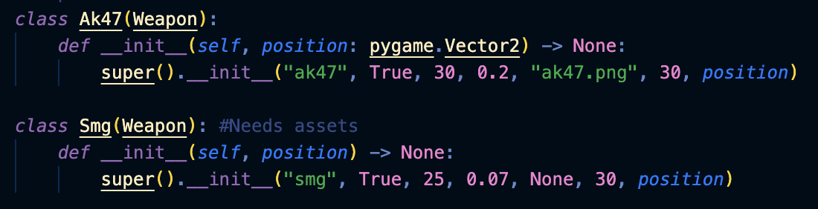

These are used by the weapon spawners.

### Weapon spawners

These are a type of tile that spawn weapons at regular intervals. They are spawned in using the same function the rest of the tiles use. They have no collision. 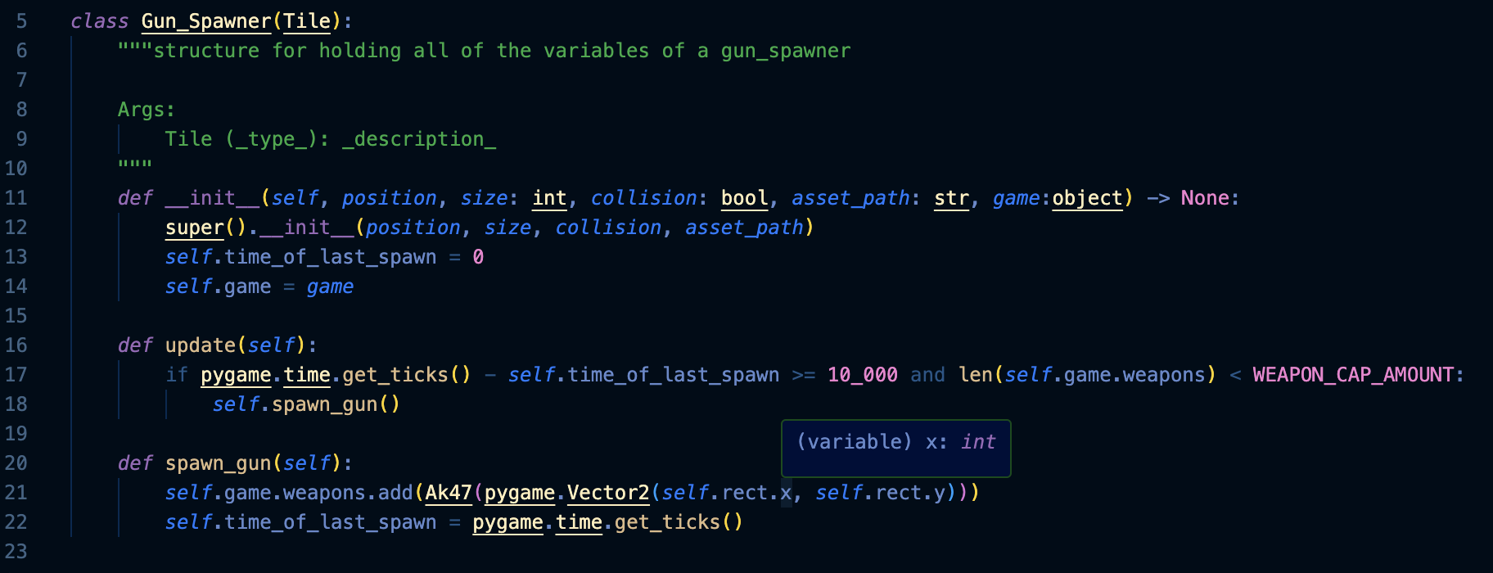

The update function is called in the game update function. Every 10 seconds the spawn_gun function is called given that there are not too many guns in the level already.

This worked well and the game spawned weapons properly. Here is a [video](https://drive.google.com/file/d/1rsIVOmUg2PJ5HekNwQeb5ymmcReF4THN/view?usp=drive_link) of testing.

### Players Interaction with weapons

Players pick up weapons when they are colliding with the weapon and they press the weapon pick up key. When they do this the players holding attribute is set to be the weapon it is colliding with. The weapon is moved to be at the position of the player. This means the weapon moves with the player. Here is the code that moves the weapon:

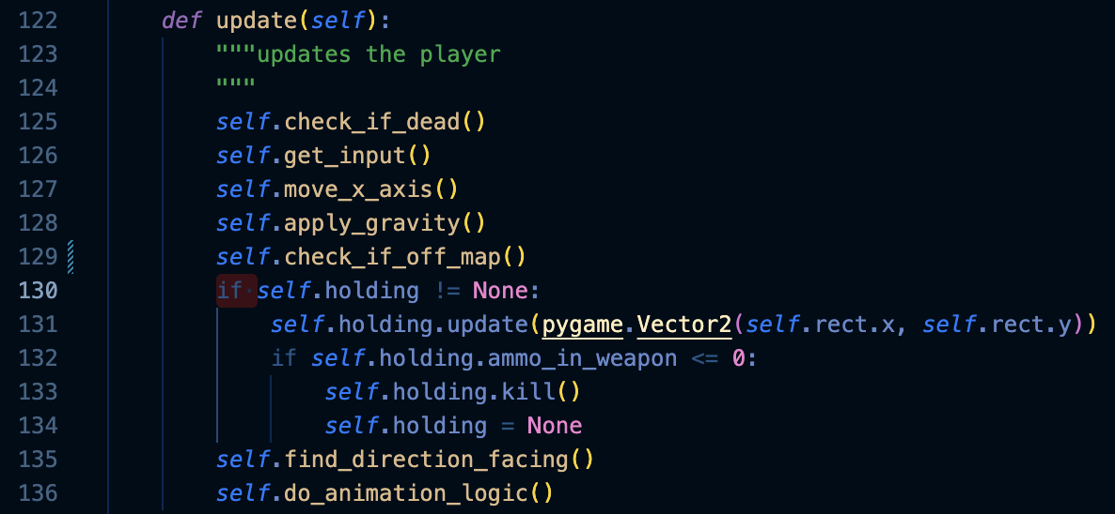

### Ammunition with weapons

When a weapon is shot its ammo attribute is decreased by one. Once the ammo attribute is decreased below 0 the gun is killed and the players holding attribute is set to None.

The code for this can be seen in the image above.

This all worked as expected. Here is an image of the player holding a weapon.

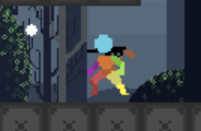

### Shooting

Shoot is a method within the player class. It initialises a Bullet and gives it a velocity that is based of the direction the player is aiming and the speed of the bullets that the weapon that the player is holding. It also decreases the ammo by one. Here is the code.

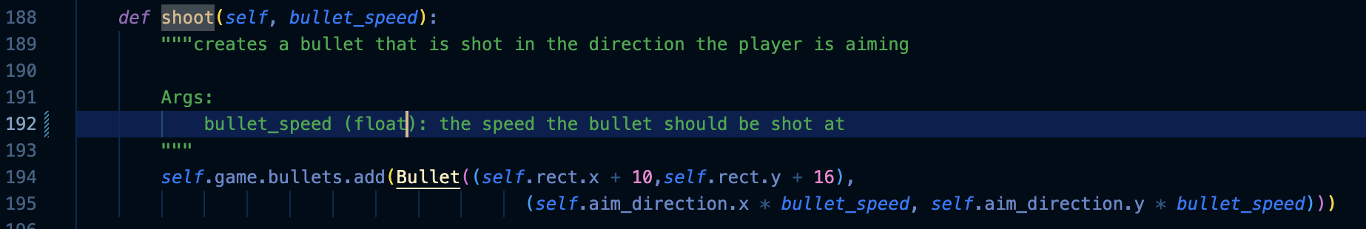

This works as it should. Here is a [video](https://drive.google.com/file/d/14C71e82aU45I4nZDnsftCJ-rCywMbGSl/view?usp=drive_link) of testing.

## Changing the structure

Since the original structure of the game was would be difficult to work with further into the game I decided to change the structure of the game to iteration 2 that can be seen in the design. Here is the code that I used.

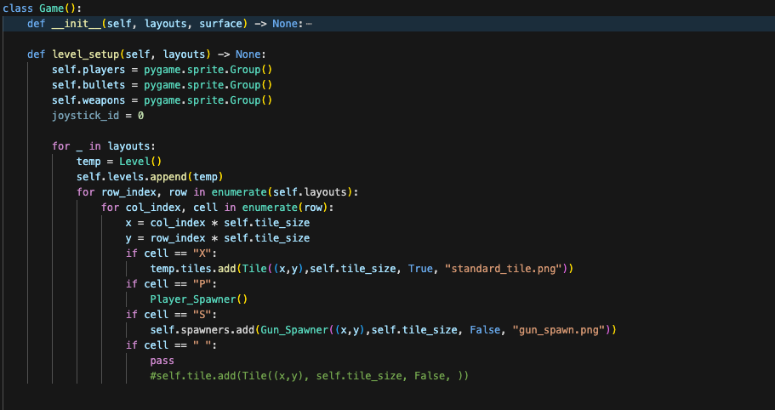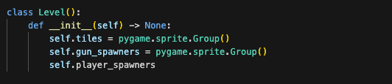

In testing of this code I found that the levels were not being displayed properly. 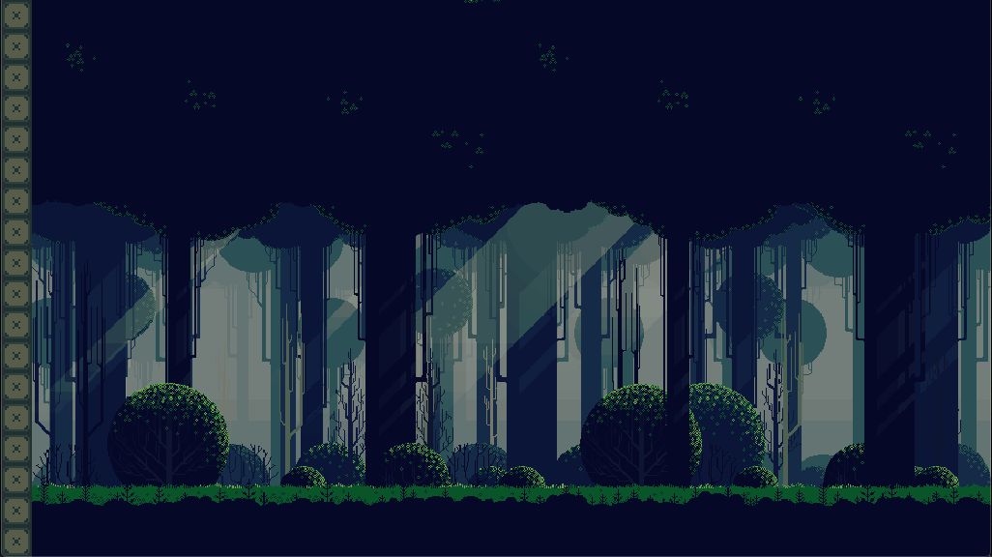

To investigate the cause of this issue I printed the layouts.



This showed that the levels were being passed into the game function as an list of maps but the program was trying to read the “layouts” as if it was a single map. This resulted in the bug that can be seen. I fixed this by reading the layouts as a list and adding each as a level.

This worked so I removed the print function.

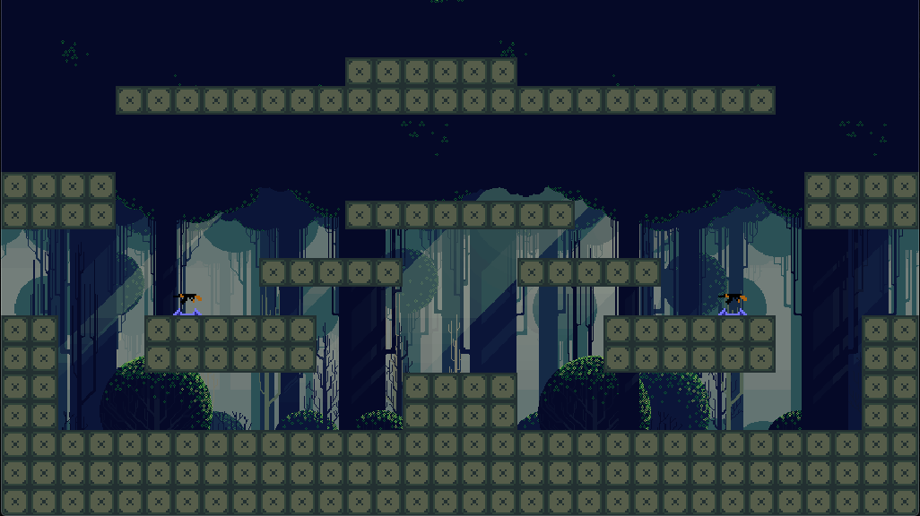

Next I needed a way to move through the levels since the way levels were being done was different. I created a function that gets called whenever the player presses the “p” key for testing to move through the levels.

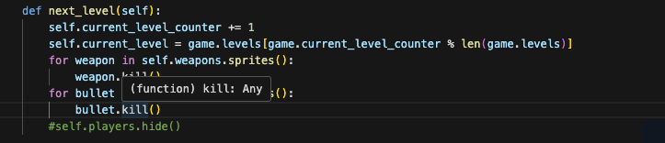

This function removes all of the non permanent parts of the game (e.g. the weapons and bullets) and loads the next levels permenant parts (e.g. the tiles). Later I will move to the next level when someone has one the round.

I created a function that spawned in the players when they hit a button on the keyboard (“e”) or when they plugged in a controller for the first time.

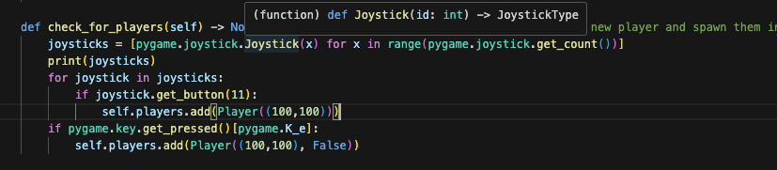

[Here](https://drive.google.com/file/d/11PVkdxy5DVjoaSnns7CypnW7Pe5-l2Tl/view?usp=drive_link) is a video of testing. When pressing e to spawn the keyboard player many players were being added. This was happening every frame. I fixed this by adding a keyboard player spawned attribute. This meant that the keyboard player could only be spawned once.

I also needed a method for moving the players into the correct place after the level was loaded as unlike before the players are the same objects throughout the game. This was the same as the algorithm in the design.

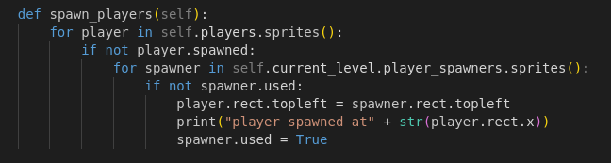

## Separating the game into multiple files

To increase the readability of the code I separated the code into multiple files. This improves the speed at which development can happen as finding code is easier.

## Animations

### Changing the direction that the player is facing

Players need to be facing to the left when they are moving to the left and facing to the right when they are moving to the right. To do this I flip the image that will be used for the player and store it in a list with the normal image. I can then choose which image I want to use depending on the velocity of the player.

Here is the code for that.



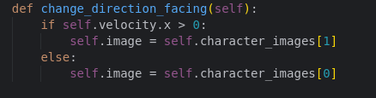

### Player animations

I also needed to create player animations. The player should run when they are moving and idle when they are standing still.

I found a free asset pack which contained a sprite sheet of different player animations for different scenarios. I also used a free program to “unpack” the images from the sprite sheet which makes them easier to use in pygame. I put the inividual frames/images into a folder.

I created two lists that contained the reversed and normal frames for the animation. I used the os library to fill these lists.

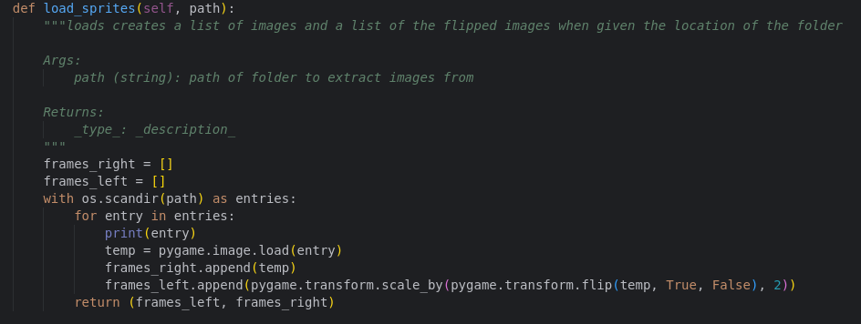

When displaying the lists I found that the animation did not look right. I printed the contents of the frames lists. <DirEntry '9.png'> <DirEntry '4.png'> <DirEntry '3.png'> <DirEntry '2.png'> <DirEntry '7.png'> <DirEntry '8.png'> <DirEntry '6.png'> <DirEntry '0.png'> <DirEntry '5.png'> <DirEntry '1.png'> <DirEntry '4.png'> <DirEntry '3.png'> <DirEntry '2.png'> <DirEntry '7.png'> <DirEntry '6.png'> <DirEntry '0.png'> <DirEntry '1.png'> <DirEntry '5.png'>

DirEntry stands for directory entry. The second part is the name of the entry. This showed that the images were not being loaded into the list alphabetically. I tried to fix this by sorting the entries list:

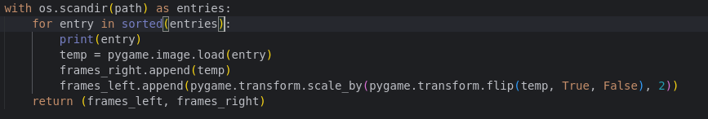

However this resulted in an error:

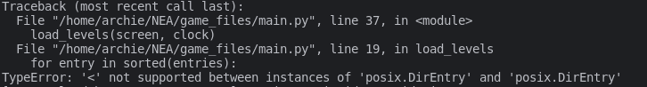

I found that the sorted function was trying to sort the items based of each item in the list however the items are classes and not strings so the sorted function can not sort them. This is the fix I made to improve the method.



It uses lamda to use the entry name as a key to sort the strings instead of the entry.

I printed the contents a second time to check if it was working:

 <DirEntry '0.png'> <DirEntry '1.png'> <DirEntry '2.png'> <DirEntry '3.png'> <DirEntry '4.png'> <DirEntry '5.png'> <DirEntry '6.png'> <DirEntry '7.png'> <DirEntry '8.png'> <DirEntry '9.png'>

All of the entries were in alphabetical order so they were being loaded in properly.

To display the animation I needed to keep track of the frames. I created a counter that gets incremented every frame and only changed the every eighth frame (an abratrary number which i may change in the future). Also depending on the direction the player is facing the program chooses between the left facing and right facing images.

This kind of worked. The player was animated but since I was changing the size of the rect the player would teleport through walls. Here is a [video](https://drive.google.com/file/d/1gQfry-BVCYTAtuLjvyaWSlnBKic7sTk7/view?usp=drive_link) of the problem. I assumed this was because the player was entering the walls and the game thought that the player had collided with the ground in a direction that had not. To fix this I would either have to change the game to use images that all have the same size (This would mean that the players hit box would be larger than it appears to be and this could make the game irratating to play). Instead I set the rect to be be set from the bottomleft of the player. This stopped the problems with the falling through the floor however when the player jumps and hits their head on the roof the player can move teleport through the ground above them.

Next I added some logic that determines if the player is moving in the x axis and shows the running animation if they are.

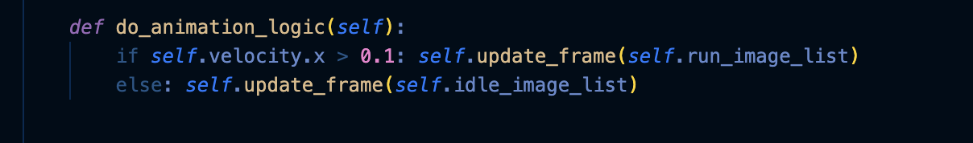

Here is a video of testing.

Since this worked I moved onto another part of the program

## Destruction

To start with I implemented a line of code within the physics method in the game class that killed a tile if it collided with a bullet.



This worked and the user can now shoot a tile and destroy it. Here is a [video](https://drive.google.com/file/d/14x8TmlIl8jKYmk9Qjulx7LAkD0tHa7Ua/view?usp=drive_link) of the destruction mechanic.

Next I needed to add a way of adding damage to the tiles. First I gave the Tiles a health attribute. And made a damage method. If the tiles health went below 0 it is killed.

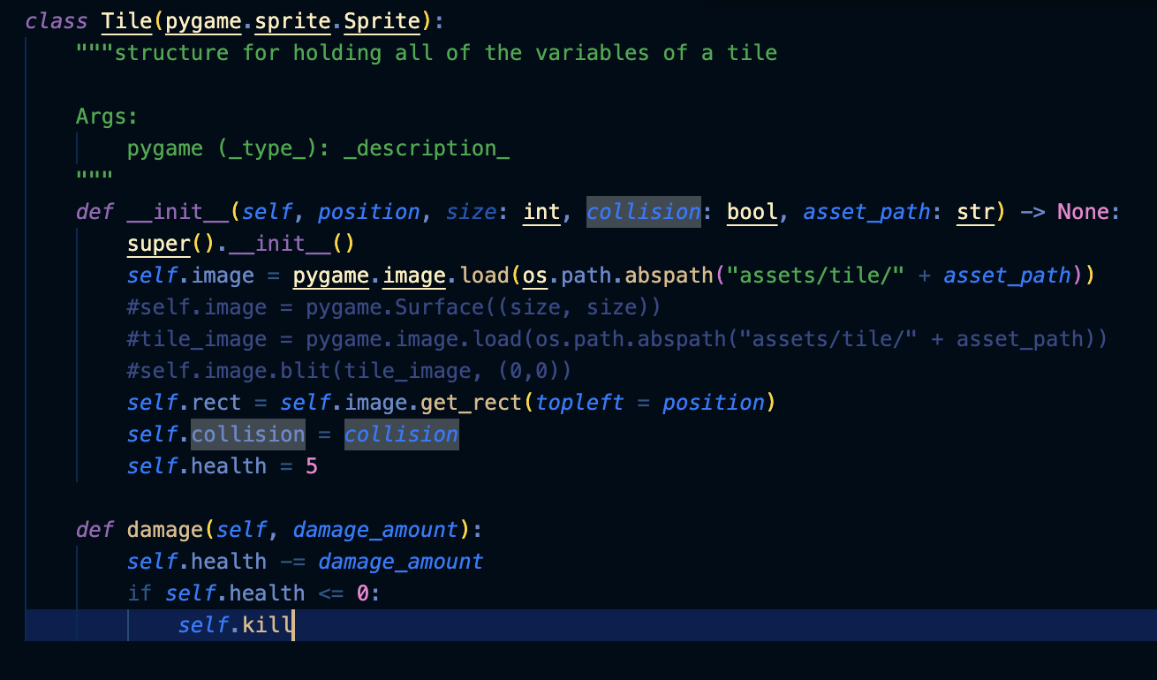

I also removed the kill line and changed it to tile.damage(1) in the bullet_collision method.

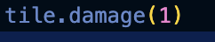

When testing I found that the would not break even after more than 5 hits from the weapon.

To understand the problem I added a breakpoint on the point where the tile.damage function is being called. I found that the health was dropping below 0 and not killing the player despite the self.kill function being called. I found that the lack of brackets on the self.kill function were the problem and after adding them the program worked properly.

Here is a [video](https://drive.google.com/file/d/1WyyRVfwBgOnxXU7Vuy51nteYcn8bY3du/view?usp=drive_link) of the working destruction. As you can see it now takes multiple hits for a tile to be destroyed.

The next step was adding a way for the players to see the health of the tiles. I did this by overlaying a breaking image over the top of the tiles image…

# Evaluation

## Post Development Testing

## Usability Features

## Evaluation